1. Run , and choose the third item 32fortran.
2. Run   
   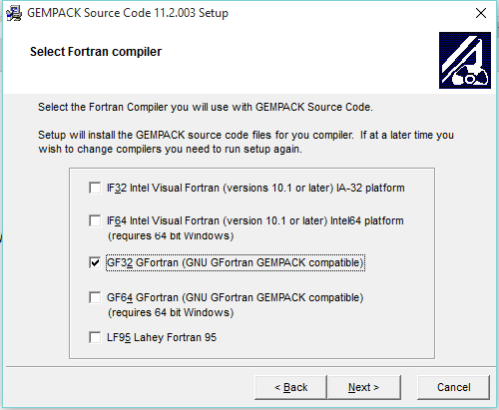
3. Copy licen.gem to installation directory

Note: The two exe files can be downloaded at: <https://pan.baidu.com/s/1pQC8fLqrOvuaOQJd45tQaQ>, Extraction code: wn9h